**DIFFERENT CULTURES**

**https://24x7offshoring.com/**

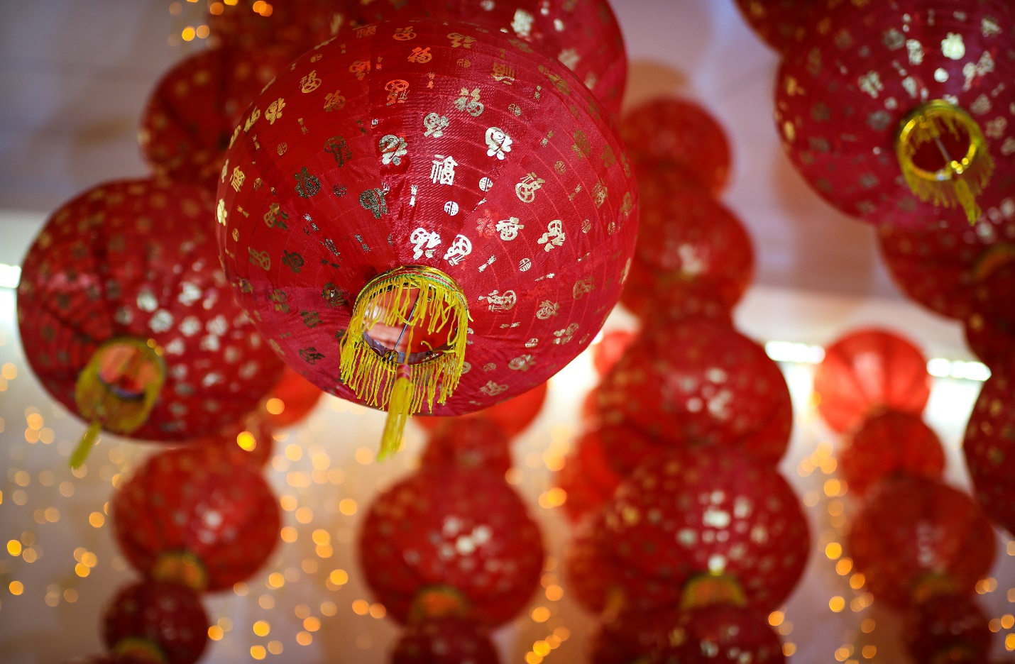[**http://24x7outsourcing.com/**](http://24x7outsourcing.com/)

**Diverse Cultural Traditions around the World**

**Extraordinary Cultural Traditions**

Custom and culture are inseparably connected.

Both have created over innumerable ages. Customs will in general be one of a kind to specific social orders and are normally brought into the world of neighborhood convictions and conditions.

These can identify with a wide range of spaces of everyday life.

**Wedding Cake, UK**

Hardly any spaces of everyday life have created however many customs throughout the years as the food that we eat.

In the UK, for instance, it's customary for a couple who wed to freeze the top level of their wedding cake and eat it a year later, on their first wedding commemoration.

Doing so should bring the couple karma. The cake doesn't ruin, as a customary wedding cake is produced using liquor drenched nut cake, finished off with marzipan and regal icing.

**Eating Jesus, Italy**

A few customs range more than one country. Strict customs are an astounding illustration of this (however there are, obviously, numerous strict practices that are remarkable to a solitary society or individuals).

From journeys to festivities on explicit days, strict practices customs all throughout the planet are hugely critical to individuals.

**Red Brides, India**

Numerous societies all throughout the planet have customs that identify with apparel.

The shading that a lady of the hour wears on her big day is frequently conventional and thought to bring best of luck. In China, ladies sport red; in the US, they will in general dress in white.

Hindu ladies will likewise be found in red, as a wedding sari or a lehenga (this contrasts as indicated by the area of India that the lady lives in).

**Jaybirds, UK**

It's not simply in the space of wedding apparel where we see customs connected to karma. For sure, numerous practices are brought into the world of strange notions – generally held however nonsensical convictions, regularly connected to karma and to the otherworldly.

Jaybirds are a magnificent illustration of this. Some Native American clans held a custom of wearing a jaybird plume as an indication of bravery.

Nonetheless, numerous Christian people group accept that seeing a solitary jaybird addresses misfortune. Over the long haul, different practices have emerged to avert that misfortune.

A few group salute, others say great morning to the performance bird, while others will agree to doffing their cap.

**Red Envelopes, China**

A lot of societies have customs that identify with occasion periods. Have you at any point nailed a stocking to the mantelpiece to Christmas Eve? Or then again left a mince pie and a drink out for Father Christmas? Alongside a carrot for Rudolph, obviously!

Occasion customs are regularly connected with eating and drinking however are absolutely not generally. In China, for instance, one custom at New Year is the giving of red envelopes containing cash. Guardians and grandparents frequently blessing these to their youngsters as a component of the festivals.

**Illustrious Worship, Vanuatu**

Many intriguing social practices have emerged over the course of the years because of individuals commending the activities or potentially lives of specific people.

For instance, have you known about the Prince Philip Movement? It is a strict group dependent on the southern island of Tanna in Vanuatu. There, the Kastom individuals around Yaohnanen town accept that Prince Philip, Duke of Edinburgh (the spouse of Queen Elizabeth II) is a heavenly being. Consistently on his birthday, they hold a customary gala with stylized moves.

**DIFFERENT CULTURES**

**https://24x7offshoring.com/**

**http://24x7outsourcing.com/**